What is optimization?

Optimization, collection of mathematical principles and methods used for solving quantitative problems in many [disciplines](https://www.merriam-webster.com/dictionary/disciplines), including [physics](https://www.britannica.com/science/physics-science), [biology](https://www.britannica.com/science/biology), [engineering](https://www.britannica.com/technology/engineering), [economics](https://www.britannica.com/money/economics), and business. The subject grew from a realization that quantitative problems in manifestly different disciplines have important mathematical elements in common. Because of this commonality, many problems can be formulated and solved by using the unified [set](https://www.britannica.com/topic/set-mathematics-and-logic) of ideas and methods that make up the field of optimization.

Type of optimization

There are three classical optimization techniques:

1. Linear Programming (LP)
2. Integer Programming (IP)
3. Nonlinear Optimization.

* **Linear optimization**

It is the procedure of searching outcomes for the finest conceivable solution from a set of parameters.

* **Integer optimization**

When parameters involved in the problem are more than one and involve integer or Boolean parameters then it becomes a problem solvable by Integer optimization.

* **Nonlinear optimization**

If the problem involves a very large set of parameters, and the solution is required to be found from that large set of constraints then it becomes a problem of Constraint optimization.

Below is an example of a maximization problem that will be solved by using integer optimization.

A maximization problem is one of a kind of integer optimization problem where constraints are provided for certain parameters and a viable solution is computed by converting those constraints into linear equations and then solving it out. We will be finding out a viable solution to the equations below.

Equations are:  3a+6b+2c <= 50

                        4a- 6b + 8c <= 45

                        3a + b – 5c <= 37

Here we need to maximize 3*a + 2*b + 2*c

1

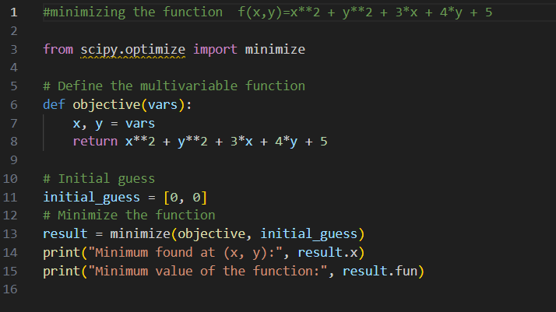

**2**

